**About Effective Teaching (Reuse from November 2011)**

**About Harry and Rosemary Wong (Reuse from November 2011)**

**How They Develop Effective Teachers (Reuse from November 2011)**

**Effective Teaching**

**By Harry and Rosemary Wong**

**December 2011/January 2012**

**The Importance of Culture**

What results would you except if you had over $15 billion to spend to effect change?

**Each year over $15 billion in Title 1 funds are made available to schools with results that are marginal.**

Now imagine a skilled teacher/consultant going into a dysfunctional school in the most impoverished school district in all of America with a mission to transform the culture of the school in one year. What would you expect? Success, of course!

This is the story of Phoenix Elementary School in Detroit, Michigan, and how money is not the greatest asset of a school; it is its people.



**The Background**

**This is a story of hope**—where there is none, perseverance—where negativity abounds, and endurance—so that every child has the opportunity to grow, learn, thrive, and achieve in a neighborhood school.

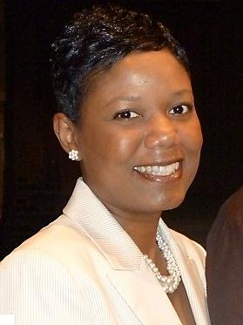In September 2009, we received a query from Jeannine Lesch, a school counselor (and this is just one of the many hats she wears) at the Phoenix Elementary School in Detroit, Michigan. She said they were in the midst of their first year of being a turnaround school and the staff was being reconstituted with 50 percent new teachers. They were looking for someone who could help them as she says, “improve their school.” **We had a prior commitment, so we recommended Chelonnda Seroyer, who had done similar work with other schools with success.**